**I Love Progmeth**

**Documentation**

**Created by**

Phatcharapon Jumruspun 6031040921

Phathit Sriburi 6031041521

**2110215 Programming Methodology**

**Semester 1 Year 2018**

**Chulalongkorn University**

I Love Progmeth Documentation

Introduction

I Love Progmeth is a turn-based game. The goal of this game is to find which player will survive. To survive in this game, a player has to fight another player by destroying all another player’s characters. When the game begins, each player has to take turn choosing three characters to form their teams. Then, the players have to fight and try to destroy the opposite team. The player who can keep their characters last longer will be the winner of this game.

User Manual

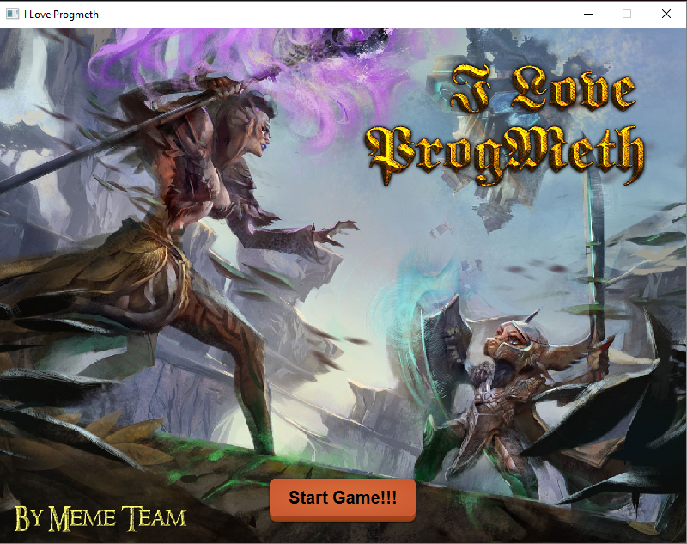Start Scene

This is the welcome page. To start the game, click “Start Game!!!” button. After you click the button, you will be presented in the CharacterSelection scene.

CharacterSelection Scene

The characterselection scene consists of 3 components.

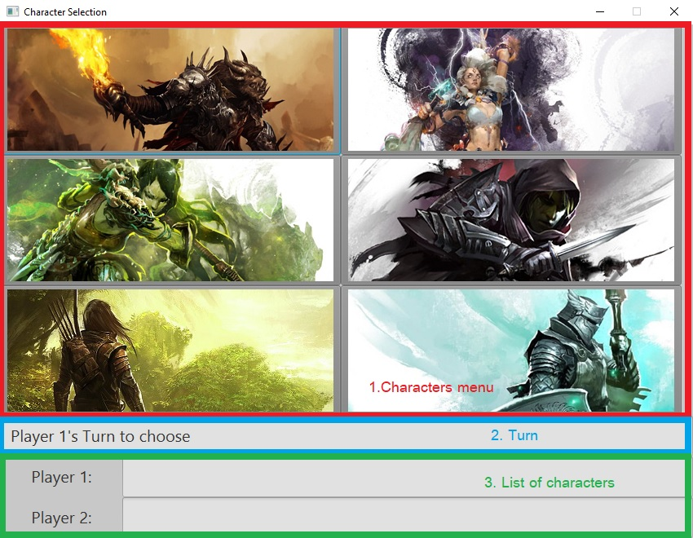

1. Character menu

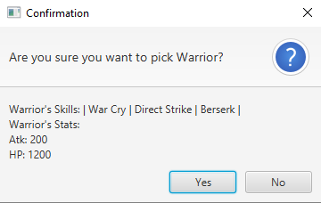Character menu is the menu that show all characters in the game. The player can click on the picture of the character to get an information of the character and to confirm choosing the character if you would like to keep the character in your list of characters.

This box appears when you click on the picture of a character.

1. Turn

This component display player’s turn to let the player that show in this component choose the character.

1. List of characters

List of characters display which character was chosen by player1 or was chosen by player2.

When player1 and player2 completely choose 3 characters in each team, you will be presented in the Battle scene.

Battle Scene

The battle scene consists of 4 major components.

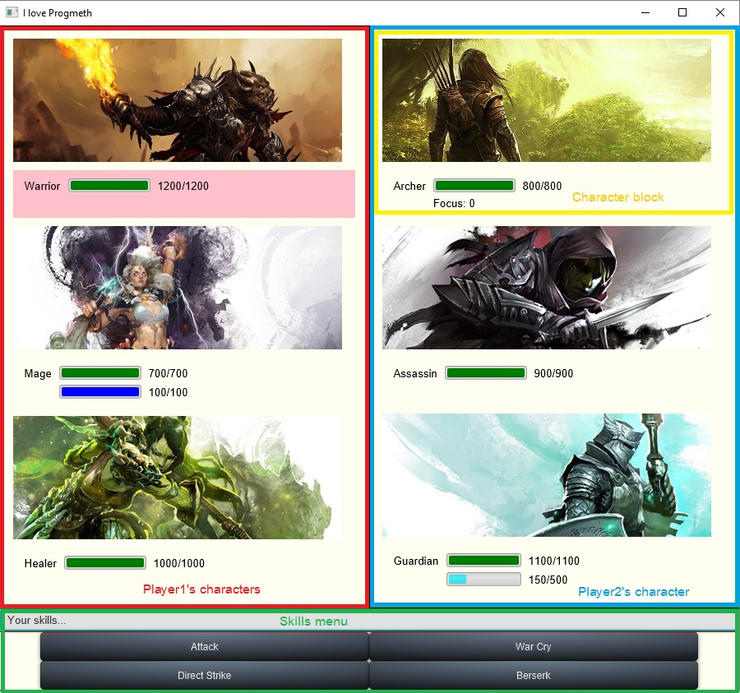

1. Player1’s characters

This part of a battle scene shows all characters that was picked in

characterselection scene by player1.

1. Player2’s characters

This part of a battle scene show all characters that was picked in

characterselection scene by player2.

1. Skill menu

The skill menu shows all skills of the character that specific by red rectangle

cover the character’s name, character’s hp and character’s status.

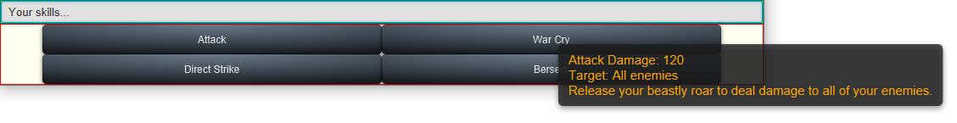

When you place the cursor on a skill bar, it will show the detail of the skill that you place the cursor on it.

1. Character block

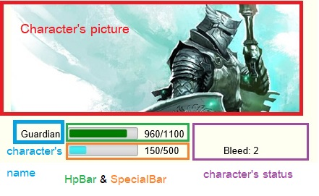The character block consists of 5 components

1. Character’s picture

This component show the picture of a character. If the character is dead, the character’s picture will change the color to black and white.

1. Character’s name

This part displays the character name.

1. HpBar

The hpbar displays how many health points you have. When the health points of the character drop to zero, it means the character is dead.

1. SpecialBar

The specialbar displays how many special points you have ,for example, mana points, focus points or virtues points. The specialbar only displays in some character block that the character has a special ability.

1. Character’s status

The character’s status show that your character has any status or not. If your character has some status such as stun, freeze, burn, bleed or shield, it will be shown in this part.

Gameplay

When you enter the game, you will be presented in the start scene

After you have clicked “Start Game!!!” button on the start scene, you will be

presented in the characterselection scene. You have to choose 3 characters to be your team and your friend has to choose 3 characters to be another team too by using the guide above.

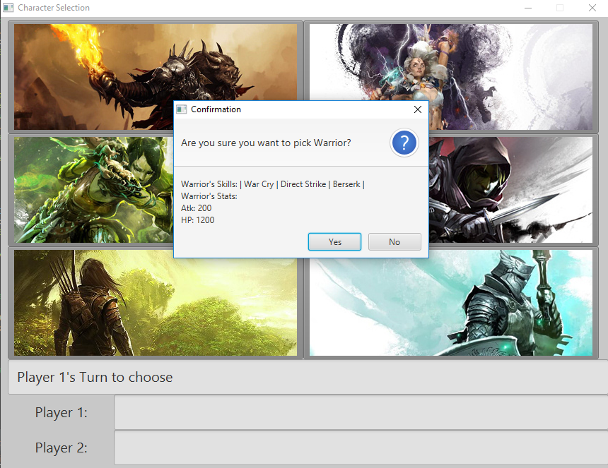

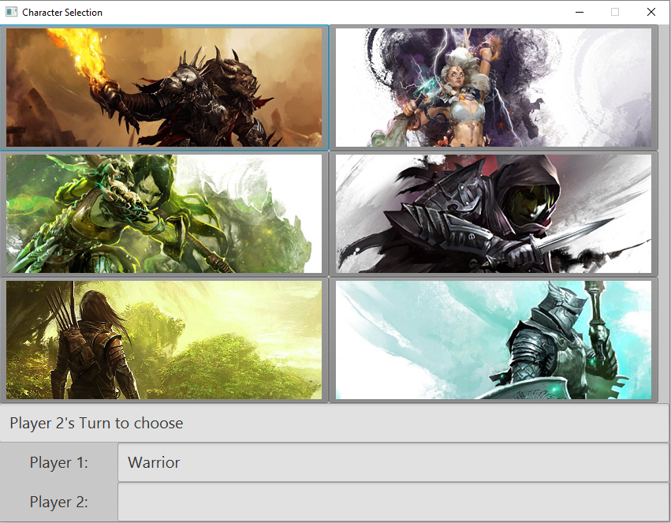When player1 select the character, the confirmation will appear to let player1 desire to choose the character or not. If player1 choose the character, the character will be listed in player1’s team and the game will change the turn to player2’s turn.

Player2 has to choose the character like player1 did.

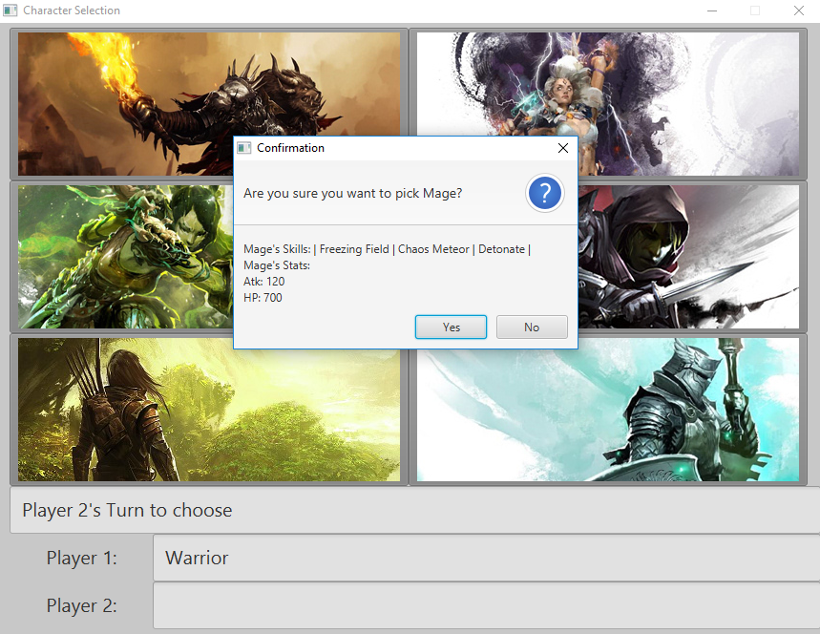

After player2 chose the character, the character will be listed in player2’s team and the game will change the turn to player1’s turn.

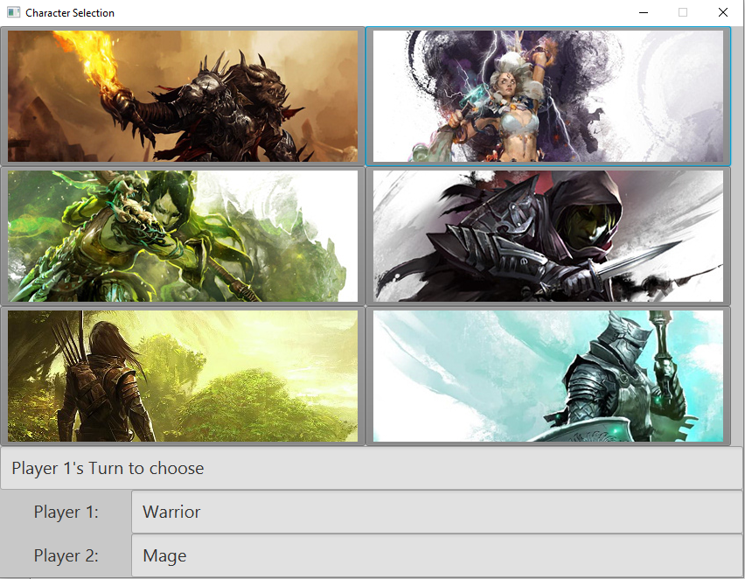

The game will repeat this sequence until player1’s team has 3 characters and player2’s team has 3 characters too.

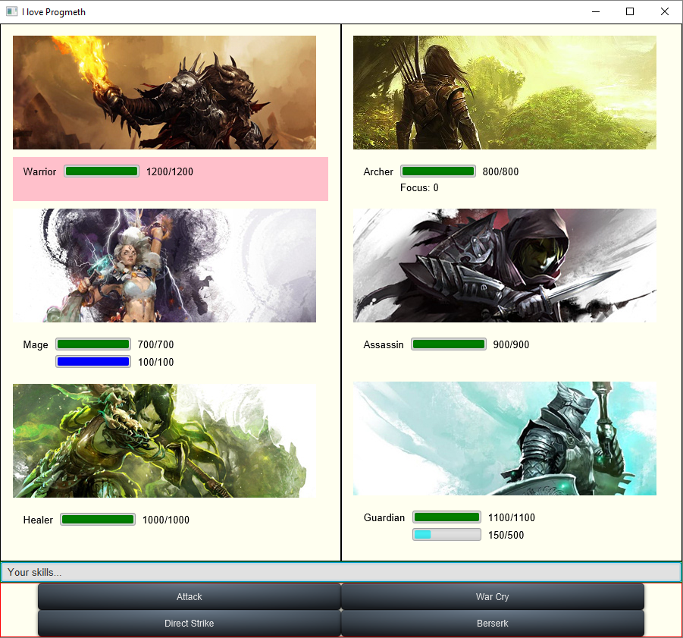As you and your friend finishing select the characters, you and your friend will be presented in the battle scene.

Player1 is the first one who can order his/her character to do something in his/her turn. After player1 complete his/her turn, player2 can order his/her character to do something in his/her turn.

When player2 complete his/her turn, the game’s turn go back to player1 again and the game will repeat this sequence until all off the characters in player1’s team or player2’s team are dead.

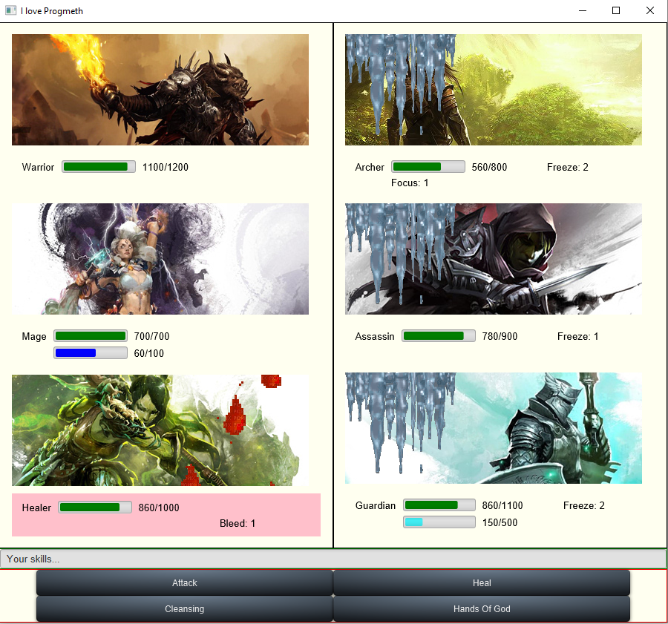The winner of this game is the player who can eliminate another player’s team first. The winner will be promoted to be the ProgMeth lover.

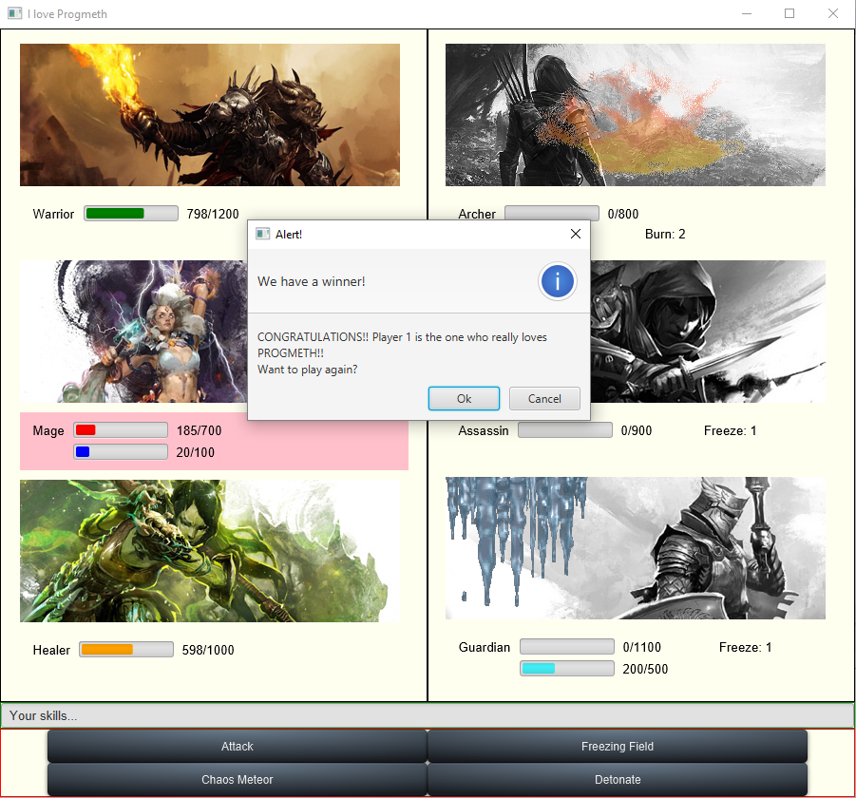

Implementation Detail

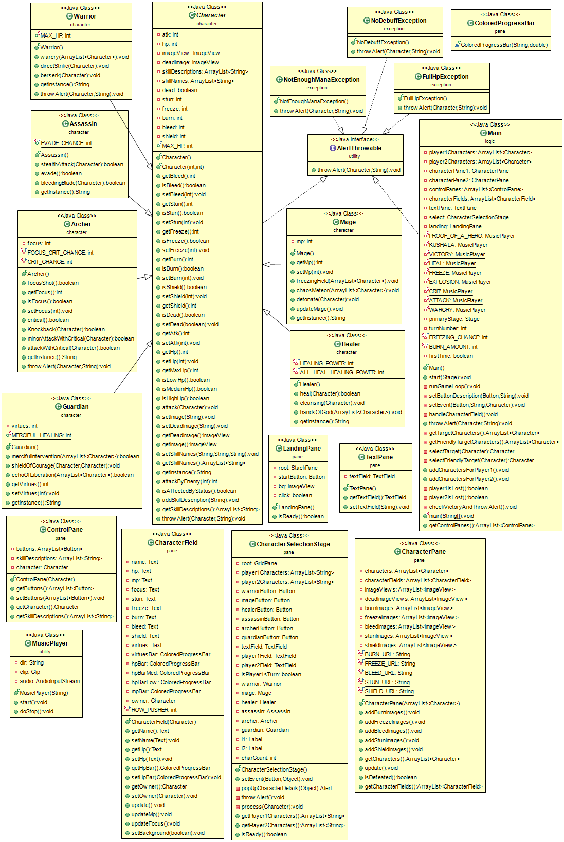

1. Package character

1.1 Class Archer

1.1.1 Field

|  |  |
| --- | --- |
| -int focus | Store focus point |
| -int FOCUS_CRIT_CHANCE | Store critical chance equals to 75 when archer is focusing |
| -int CRIT_CHANCE | Store critical chance equals to 30 when archer is not focusing |

1.1.2 Constructor

|  |  |
| --- | --- |
| + Archer() | Set the corresponding fields to the basic values |

1.1.3 Method

|  |  |
| --- | --- |
| + boolean focusShot() | If archer doesn’t focus,this method will set focus equals to 2 |
| + int getFocus() | Return focus value |
| + boolean isFocus() | Return true if focus value is more than 0 ,return false otherwise |
| + void setFocus(int focus) | Set focus value |
| + boolean critical() | Return critical chance randomly |
| + boolean Knockback(Character enemy) | Return random chance to get 1 or 2 focus point and return random chance to stun enemy |
| + boolean minorAttackWithCritical (Character enemy) | If archer attack without critical,the damage will be reduced to a half of attack point |
| + boolean attackWithCritical (Character enemy) | If archer attack with critical,the damage will be multiply by 2 |
| + String getInstance() | Return “Archer” |
| + void throwAlert(Character character,String reason) | Alert a message when the archer has some special action |

1.2 Class Assasin

1.2.1 Field

|  |  |
| --- | --- |
| -int EVADE_CHANCE | Store evade chance equals to 30 |

1.2.2 Constructor

|  |  |
| --- | --- |
| + Assasin() | Set the corresponding fields to the basic values |

1.2.3 Method

|  |  |
| --- | --- |
| + boolean stealthAttack(Character enemy) | When enemy’s health points is lower than 35%,assassin will attack the enemy with double damage |
| + boolean evade() | Return chance to evade the attacker |
| + boolean bleedingBlade(Character enemy) | Make target bleed with damage |
| + String getInstance() | Return “Assasin” |

1.3 Class Character

This abstract class represents the basic model of all characters in this game

1.3.1 Field

|  |  |
| --- | --- |
| -int atk | Store attack point of the character |
| -int hp | Store health point of the character |
| -imageView ImageView | Store the picture of the character |
| -imageView deadImage | Store the picture of the character when the character is dead |
| -ArrayList<String> skillDescriptions | Store all description of skills that the character has |
| -ArrayList<String> skillNames | Store all names of skills that the character has |
| -boolean dead | Store the value of the character to check that the character is dead or alive |
| -int stun | Store the stun values of the character |
| -int freeze | Store the freeze values of the character |
| -int burn | Store the burn values of the character |
| -int bleed | Store the bleed values of the character |
| -int shield | Store the shield values of the character |
| -int MAX_HP | Store max health point of the character |

1.3.2 Constructor

|  |  |
| --- | --- |
| + Character() | Set the corresponding fields to the basic values |
| + Character(int atk,int hp) | Set the corresponding fields to the parameters |

1.3.3 Method

|  |  |
| --- | --- |
| + int getBleed() | Return bleed values |
| + boolean isBleed() | Return true if the character’s bleed points is more than zero ,return false otherwise |
| + void setBleed(int bleed) | Set bleed values to the parameter value |
| + int getStun() | Return stun values |
| + boolean isStun() | Return true if the character’s stun points is more than zero ,return false otherwise |
| + void setStun(int stun) | Set stun values to the parameter value |
| + int getFreeze() | Return freeze values |
| + boolean isFreeze() | Return true if the character’s freeze points is more than zero ,return false otherwise |
| + void setFreeze(int freeze) | Set freeze values to the parameter value |
| + int getBurn() | Return burn values |
| + boolean isBurn() | Return true if the character’s burn points is more than zero ,return false otherwise |
| + void setBurn(int burn) | Set burn values to the parameter value |
| + int getShield() | Return shield values |
| + boolean isShield() | Return true if the character’s shield points is more than zero ,return false otherwise |
| + void setShield(int shield) | Set shield values to the parameter value |
| + boolean isDead(boolean dead) | Return true if the character is dead ,return false otherwise |
| + void setDead(boolean dead) | Set dead values to the parameter value |
| + int getAtk() | Return attack values |
| + void setAtk(int atk) | Set attack values to the parameter value |
| + int getHp() | Return health points of the character |
| + void setHp(int hp) | Set health points to the parameter value |
| + int getMaxHp() | Return max health points of the character |
| + boolean isLowHp() | Return true if the character’s health points is lower than 35%,return false otherwise |
| + boolean isMediumHp() | Return true if the character’s health points is between 35% and 59.9%,return false otherwise |
| + boolean isHighHp() | Return true if the character’s health points is more than 59.9%,return false otherwise |
| + void attack(Character enemy) | Attack the enemy |
| + void setImage(String url) | Set the image of the character |
| + void setDeadImage(String url) | Set the dead image of the character |
| + ImageView getDeadImage() | Return the dead image of the character |
| + ImageView getImage() | Return the image of the character |
| + void setSkillNames(String s1,String s2,String s3) | Set all skill’s names |
| + ArrayList<String> getSkillNames | Return arraylist of all skill’s names |
| + String getInstance() | Return “Character” |
| + int attackByEnemy(int damage) | Decrease the character’s health points with the parameter |
| + boolean isAffectedByStatus() | Return true if the character get some bad status,return false otherwise |
| + void addSkillDescription(String s) | Add description of the skill |
| + ArrayList<String> getSkillDescriptions() | Return all skill’s descriptions |
| + void throwAlert(Character character,String reason) | Alert a message when the character has some special action |

1.4 Class Guardian

1.4.1 Field

|  |  |
| --- | --- |
| -int virtues | Store virtues points of the character |
| -int MERCFUL_HEALING | Store merciful healing points of the character |

1.4.2 Contructor

|  |  |
| --- | --- |
| + Guardian() | Set the corresponding fields to the basic values |

1.4.3 Method

|  |  |
| --- | --- |
| + boolean mercifulIntervention(ArrayList<Character> friends) | Heal all of the guardian’s team and collect virtues points |
| + void shieldOfCourage(Character enemy,Character friend) | Attack the enemy and add a shield point to the guardian’s friend |
| + boolean echoOfLiberation(ArrayList<Character enemies>) | Attack all enemies with a half of attack points plus a half of virtues points |
| + int getVirtues() | Return virtues points |
| + void setVirtues(int virtues) | Set virtues points of the character to the parameter value |
| + String getInstance() | Return “Guardian” |

1.5 Class Healer

1.5.1 Field

|  |  |
| --- | --- |
| -int HEALING_POWER | Store healing values |
| -int ALL_HEALING_POWER | Store healing all members in the team values |

1.5.2 Constructor

|  |  |
| --- | --- |
| + Healer() | Set the corresponding fields to the basic values |

1.5.3 Method

|  |  |
| --- | --- |
| + boolean heal(Character friend) | Recovery your friend’s health points |
| + void cleansing(Character friend) | Delete all bad status of healer’s friend |
| + void handsOfGod(ArrayList<Character> friends) | Recovery every member’s health points |
| + String getInstance() | Return “Healer” |

1.6 Class Mage

1.6.1 Field

|  |  |
| --- | --- |
| - int mp | Store mana points |

1.6.2 Constructor

|  |  |
| --- | --- |
| + Mage() | Set the corresponding fields to the basic values |

16.3 Method

|  |  |
| --- | --- |
| + int getMp() | Return mana points |
| + void setMp(int mp) | Set mana points to the parameter value |
| + void freezingField(ArrayList<Character> characters) | Attack all enemies and set freeze status of all enemies to 2 |
| + void chaosMeteor(ArrayList<Character> characters) | Attack all enemies and set burn status of all enemies to 2 |
| + void detonate(Character character) | Attack the enemy by (100-usedMp) multiply by 5  Throw NotEnoughManaException if MP is not enough to use |
| + void updateMage() | Add 15 mana points |
| + String getInstance() | Return “Mage” |

1.7 Class Warrior

1.7.1 Field

|  |  |
| --- | --- |
| -int MAX_HP | Store max health points of the warrior |

1.7.2 Constructor

|  |  |
| --- | --- |
| + Warrior() | Set the corresponding fields to the basic values |

1.7.3 Method

|  |  |
| --- | --- |
| + void warcry(ArrayList<Character> enemies) | Attack all enemies with 120 damages |
| + void directStrike(Character enemy) | Attack the enemy and stun the enemy |
| + void berserk(Character enemy) | Attack the enemy with max health points minus recent health points |
| + String getInstance() | Return “Warrior” |
| + void throwAlert(Character character,String reason) | Alert a message when the warrior has some special action |

2. Package logic

2.1 Class Main

2.1.1 Field

|  |  |
| --- | --- |
| - ArrayList<Character> player1characters | Store player 1’s selected Characters |
| - ArrayList<Character> player2characters | Store player 2’s selected Characters |
| - CharacterPane characterPane1 | Display player 1’s selected Characters |
| - CharacterPane characterPane2 | Display player 2’s selected Characters |
| - ArrayList<ControlPane> controlPanes | Store all Characters’ ControlPanes |
| - ArrayList<CharacterField> characterFields | Store all Characters’ CharacterFields |
| - TextPane textPane | Store TextPane used to display “Your skills…” |
| - CharacterSelectionStage select | Store CharacterSelectionStage and return an ArrayList of selected Characters to be used in the gameplay |
| - LandingPane landing | Store a LandingPane which is use as a title screen |
| - MusicPlayer PROOF_OF_A_HERO | Store a MusicPlayer that contains a music “Proof of a Hero” |
| - MusicPlayer KUSHALA | Store a MusicPlayer that contains a music “Kushala” |
| - MusicPlayer VICTORY | Store a MusicPlayer that contains a music “Victory” |
| - MusicPlayer HEAL | Store a healing sound effect |
| - MusicPlayer FREEZE | Store a freezing sound effect |
| - MusicPlayer EXPLOSION | Store a explosion sound effect |
| - MusicPlayer CRIT | Store a critical sound effect |
| - MusicPlayer ATTACK | Store an attack sound effect |
| - MusicPlayer WARCRY | Store a warcry sound effect |
| - Stage primaryStage | Store a primaryStage from the start() method |
| - int turnNumber | Store current turn order |
| - int FREEZING_CHANCE | Store the percentage number of freezing chance |
| - int BURNING_AMOUNT | Store the burn tick damage |
| - boolean firstTime | Store a boolean the check if the player is playing for the first time or not |

2.1.2 Method

|  |  |
| --- | --- |
| + void addCharactersForPlayer1() | Receive the returned ArrayList<String> from “select” variable and add the respective Characters into the player1Characters |
| + void addCharactersForPlayer2() | Receive the returned ArrayList<String> from “select” variable and add the respective Characters into the player2Characters |
| - void checkVictoryAndThrowAlert() | Check if there’s a winner or not, if yes then throw alert to ask the users whether they want to continue playing or not |
| + getControlPanes() | Return controlPanes |
| - ArrayList<Character> getFriendlyTargetCharacters() | Return the current turn owner’s allies |
| - ArrayList<Character> getTargetCharacters() | Return the current turn owner’s enemies |
| - void handleCharacterField() | Update all the CharacterField’s information |
| - boolean player1isLost() | Return true if player 1’s characters are all dead, else return false |
| - boolean player2isLost() | Return true if player 2’s characters are all dead, else return false |
| - void runGameLoop() | Update the turn and check the status effects on the current Character and allies its effect to them |
| - Character selectFriendlyTarget(Character character) | Pop up an alert to let the player choose their ally target, then return the selected ally |
| - Character selectTarget(Character character) | Pop up an alert to let the player choose their enemy target, then return the selected enemy |
| - void setButtonDescription(Button b, String description) | Set the button’s tooltip to show their skill’s description |
| - void setEvent(Button b, String skillName, Character character) | Set the event handler when the button is pressed to activate the respective skill |
| + void start(Stage primaryStage) | Function used to start the application |
| + void throwAlert(Character character, String reason) | Alert a message when the characters have some special action |

3. Package pane

3.1 Class CharacterField

3.1.1 Field

|  |  |
| --- | --- |
| -Text name | Store name of the characterfield in Text form |
| -Text hp | Store health points of the characterfield in Text form |
| -Text mp | Store mana points of the characterfield in Text form |
| -Text focus | Store focus points of the characterfield in Text form |
| -Text stun | Store stun points of the characterfield in Text form |
| -Text freeze | Store freeze points of the characterfield in Text form |
| -Text burn | Store burn points of the characterfield in Text form |
| -Text bleed | Store bleed points of the characterfield in Text form |
| -Text shield | Store shield points of the characterfield in Text form |
| -Text virtues | Store virtues points of the characterfield in Text form |
| -ColoredProgressBar virtuesBar | Store virtues points of the characterfield in ColoredProgressBar form |
| -ColoredProgressBar hpBar | Store health points of the characterfield in ColoredProgressBar form |
| -ColoredProgressBar hpBarMed | Store health points of the characterfield in ColoredProgressBar form |
| -ColoredProgressBar HpBarLow | Store health points of the characterfield in ColoredProgressBar form |
| -ColoredProgressBar mpBar | Store mana points of the characterfield in ColoredProgressBar form |
| -Character owner | Store owner of the characterfield |
| -int ROW_PUSHER | Store row of the game |

3.1.2 Constructor

|  |  |
| --- | --- |
| + CharacterField(Character character) | Set the corresponding fields to the parameter value |

3.1.3 Method

|  |  |
| --- | --- |
| + Text getName() | Return name of the characterfield |
| + void setName(Text name) | Set name values to the parameter value |
| + Text getHp() | Return health points of the characterfield |
| + void setHp(Text hp) | Set Health points to the parameter value |
| + ColoredProgressBar getHpBar() | Return ColoredProgressBar of health points |
| + void setHpBar(ColoredProgressBar hpBar) | Set ColoredProgressBar of health points to the parameter value |
| + Character getOwner() | Return the owner of the characterfield |
| + void setOwner(Character owner) | Set the owner value to the parameter value |
| + void update() | Update the characterfield |
| + void updateMp() | Update mp of the characterfield |
| + void updateFocus() | Update focus points of the characterfield |
| + void setBackground(boolean b) | Set background of the characterfield |

3.2 Class CharacterPane

3.2.1 Field

|  |  |
| --- | --- |
| -ArrayList<Character> characters | Store all characters |
| -ArrayList<Character> characterFields | Store all characterfields |
| -ArrayList<ImageView> imageViews | Store all character’s images |
| -ArrayList<ImageView> deadImageViews | Store all character’s dead images |
| -ArrayList<ImageView> burnImages | Store burning images |
| -ArrayList<ImageView> freezeImages | Store freezing images |
| -ArrayList<ImageView> bleedImages | Store bleeding images |
| -ArrayList<ImageView> stunImages | Store stuning images |
| -ArrayList<ImageView> shieldImages | Store shield images |
| -String BURN_URL | Store location of a burning image |
| -String FREEZE_URL | Store location of a freezing image |
| -String BLEED_URL | Store location of a bleeding image |
| -String STUN_URL | Store location of a stunning image |
| -String SHIELD_URL | Store location of a shield image |

3.2.2 Constructor

|  |  |
| --- | --- |
| + CharacterPane(ArrayList<Character> characters) | Set the corresponding fields to the parameter value |

3.2.3 Method

|  |  |
| --- | --- |
| + void addBurnImages() | Add burning images |
| + void addFreezeImages() | Add freezing images |
| + void addBleedImages() | Add bleeding images |
| + void addStunImages() | Add stunning images |
| + void addShieldImages() | Add shield images |
| + ArrayList<Character> getCharacters() | Return all characters |
| + void update() | Update the characterpane |
| + boolean isDefeated() | Return true if this character is defeated,return false otherwise |
| + ArrayList<CharacterField> getCharacterFields() | Return all characterfields |

3.3 Class CharacterSelectionStage

3.3.1 Field

|  |  |
| --- | --- |
| -GridPane root | Store gridpane |
| -ArrayList<String> player1Characters | Store player1’s characters |
| -ArrayList<String> player2Characters | Store player2’s characters |
| -Button warriorButton | Store a button with warrior’s picture |
| -Button mageButton | Store a button with mage’s picture |
| -Button healerButton | Store a button with healer’s picture |
| -Button assasinButton | Store a button with assasin’s picture |
| -Button archerButton | Store a button with archer’s picture |
| -Button guardianButton | Store a button with guardian’s picture |
| -TextField textField | Store textfield |
| -TextField player1Field | Store textfield of player1 |
| -TextField player2Field | Store textfield of player2 |
| -boolean isPlayer1sTurn | Store turn of a player |
| -Warrior warrior | Store warrior class |
| -Mage mage | Store mage class |
| -Healer healer | Store healer class |
| -Assasin assassin | Store assassin class |
| -Archer archer | Store archer class |
| -Guardian guardian | Store guardian class |
| -Label l1 | Store label values |
| -Label l2 | Store label values |
| -int charCount | Store the number of characters |

3.3.2 Constructor

|  |  |
| --- | --- |
| + CharacterSelectionState() | Set the corresponding fields to the basic value |

3.3.3 Method

|  |  |
| --- | --- |
| + void setEvent(Button b,Object character) | Set event to the button |
| -Alert popUpCharacterDetails(Object o) | Alert popup |
| -void throwAlert() | Alert error popup |
| -void process(character.Character character) | Capture the result and add to arraylist |
| + ArrayList<String> getPlayer1Characters() | Return player1’s characters |
| + ArrayList<String> getPlayer2Characters() | Return player2’s characters |
| + boolean isReady() | Return true if the number of characters equal to 6 , return false otherwise |

3.4 Class ColoredProgressBar

3.4.1 Constructor

|  |  |
| --- | --- |
| + ColoredProgressBar(String styleClass,double progress) | Set the corresponding fields to the parameter value |

3.5 Class ControlPane

3.5.1 Field

|  |  |
| --- | --- |
| -ArrayList<Button> buttons | Store all buttons |
| -ArrayList<String> skillDescriptions | Store all skill’s descriptions |
| -Character character | Store a character |

3.5.2 Constructor

|  |  |
| --- | --- |
| + ControlPane(Character character) | Set the corresponding fields to the parameter value |

3.5.3 Method

|  |  |
| --- | --- |
| + ArrayList<Button> getButtons() | Return all buttons |
| + void setButtons(ArrayList<Button> buttons) | Set all buttons to parameter values |
| + Character getCharacter() | Return the character |
| + ArrayList<String> getSkillDescriptions() | Return all skill’s descriptions |

3.6 Class LandingPane

3.6.1 Field

|  |  |
| --- | --- |
| -StackPane root | Store stackpane |
| -Button startButton | Store starting button |
| -ImageView bg | Store background image |
| -boolean click | Store click value |

3.6.2 Constructor

|  |  |
| --- | --- |
| + LandingPane() | Set the corresponding fields to the basic value |

3.6.3 Method

|  |  |
| --- | --- |
| + isReady() | Return true if a player click startbutton ,return false otherwise |

3.7 Class TextPane

3.7.1 Field

|  |  |
| --- | --- |
| -TextField textField | Store textfield values |

3.7.2 Constructor

|  |  |
| --- | --- |
| + TextPane() | Set the corresponding fields to the basic value |

3.7.3 Method

|  |  |
| --- | --- |
| + TextField getTextField() | Return the textfield of this class |
| + void setTextField(String text) | Set textfield value to the parameter value |

4. Package utility

4.1 Interface AlertThrowable

This Interface represents the ability of the class to be able to throw out the alert

4.1.1 Method

|  |  |
| --- | --- |
| + void throwAlert(Character character, String reason) | Alert a message when the characters have some special action |

4.2 Class MusicPlayer

4.2.1 Field

|  |  |
| --- | --- |
| - String dir | Store .wav’s file directory |
| - Clip clip | Store Clip variable |
| - AudioInputStream audio | Store AudioInputStream variable |

4.2.2 Constructor

|  |  |
| --- | --- |
| + MusicPlayer(String dir) | Construct a MusicPlayer object with the instantiated directory |

4.2.3 Method

|  |  |
| --- | --- |
| + void start() | Start playing a music that is loaded in the class |
| + void doStop() | Stop playing a currently playing music |

5. Package exception

5.1 Class NotEnoughManaException

Throw this exception when a mage trying to use a skill but she doesn’t have enough mana

5.2 Class NoDebuffException

Throw this exception when a healer trying to cleanse a debuff but the target doesn’t have one

5.3 Class FullHpException

Throw this exception when a healer trying to use “Hands of God” skill while all of her teammates are still at full HP